CHAPTER 1
FAKE NEWS DETECTION USING NLP AND MACHINE LEARNING

INTRODUCTION
Fake news is untrue information presented as news. It often has the aim of damaging the reputation of a person or entity or making money through advertising revenue. Once common in print, the prevalence of fake news has increased with the rise of social media, especially the Facebook News Feed.
During the 2016 US presidential election, various kinds of fake news about the candidates widely spread in the online social networks, which may have a significant effect on the election results. According to a post-election statistical report, online social networks account for more than 41.8% of the fake news data traffic in the election, which is much greater than the data traffic shares of both traditional TV/radio/print medium and online search engines respectively.
Fake news detection is becoming increasingly difficult because people who have ill intentions are writing the fake pieces so convincingly that it is difficult to separate from real news. What we have done is a simplistic approach that looks at the news headlines and tries to predict whether they may be fake or not. Fake news can be intimidating as they attract more audience than normal. People use them because this can be a very good marketing strategy. But the money earned might not live up to fact that it can harm people.

1.1 AIM:
Aim of the project is to develop a FAKE NEWS DETECTION system using natural language processing and its accuracy will be tested using machine learning algorithms.

1.2 SCOPE:
Fake news has a negative impact on individuals and society; hence the detection of fake news is becoming a bigger field of interest for data scientists. Attempts to leverage artificial intelligence technologies particularly machine/deep learning techniques and natural language processing (NLP) to automatically detect fake news and prevent its viral spread have recently been actively discussed.
Large technology companies have begun to take steps to address this trend. For example, Google has adjusted its news rankings to prioritize well-known sites and has banned sites with a history of spreading fake news. Facebook has integrated fact checking organizations into its platform.

1.3 OBJECTIVES:
- To develop a model that classifies given news article as either fake or true.
- To develop a method for detecting and classifying the news stories using Natural Language Processing.
- To identify fake news, which is a classic text classification issue.
- To gather the data, pre-processed the text, and translated the articles into supervised model features.

CHAPTER 2
LITERATURE SURVEY
2.1 LITERATURE SURVEY PAPERS
2.1.1 Fake News detection using Naive Byes, SVM, Neural Network and LSTM:
Author Name: Poonam Tijare.
Year: 2020.
Over the last decade, there have encounters of flux in misinformation that spread like wildfires. The surge in fake news was noticed during the 2016 presidential elections that happened in the US that determined the fate of these elections. In many cases, it is seen that the sharing of hoax news has been more than that of accurate news. In a massive market like India, the scope of fake news propaganda has been artfully misused by many groups. Accounting to the expeditious digitization across all channels and mediums, the menace of fake news has been burgeoning at a colossal scale. Majority of the Countries all across the world are trying to combat this challenge. This paper explores the application of Natural Language Processing and Machine Learning techniques to identify fake news accurately. Pre-processing tools are used to clean the data and apply feature extraction on them. Then a fake news detection model is built using four different techniques. Finally, the paper investigates and compares the accuracy of techniques which are Naive Bayes, Support Vector Machine (SVM), neural network and long short-term memory (LSTM) to find the best fit for the model.

Fake News detection using NLP:
Author Name: Lakshmi Panneerselvam.
Year: 2021.
The major objective of watching or reading news was to be informed about whatever is happening around us. There are several social media platforms in the current modern era, like Facebook, Twitter, Reedit, and so forth where millions of users would rely upon for knowing day-to-day happenings. Then came the fake news which spread across people as fast as the real news could. Fake news is a piece of incorporated or falsified information often aimed at misleading people to a wrong path or damage a person or an entity‘s reputation.
The PAC algorithm responds aggressively to incorrect predictions and remains passive for the correct predictions. By using this algorithm, the accuracy is 92%. Multinomial Naïve Bayes algorithm considers the integer feature counts where it represents how often or how many times a specific word appears. It is much suitable for the classification of discrete features. i.e., word counts for classifying a text. The Prediction Accuracy we‘ve got here is 90%. They can print a confusion matrix to gain insight into the number of false and true negatives and positives.

Fake News Detection Using N-Gram Analysis and Machine Learning Algorithms:
Author Name: Asha J. and Meenakowshalya A.
Year: 2022
Fake news is untrue information presented as news. Fake news easily spread than real news amongst social networking sites. The main challenge in fake news detection is limited availability of resources (datasets). This project work detects fake news using n-gram analysis and machine learning algorithms. Today‘s revolutionary false information is news, stories or hoaxes created to deliberately misinform. The false information‘is a team refer to a diverse range of disinformation covering topics such as health economics and education so on. It often has the aim of damaging the reputation of a person or object, or making money through advertising income. The main concept of fake news is not an emerging concept. In this paper, a detection model for fake news was using n-gram analysis through different features extraction techniques and machine learning algorithms. Furthermore, project investigated two different features extraction techniques and six different machine learning techniques. The proposed methodology gives highest accuracy when using unigram features (N=1) and SGD classifier (Machine learning). The highest accuracy score is 93.5%, performance tuning is applied on SGD, to find best parameter for enhance the accuracy by using Grid Search CV and Random Search CV, among both Random Search CV yields more accuracy of 94.2%.

2.1.4 A Taxonomy of Fake News Classification Techniques:
Author Name: Dhiren Rohera, Harshal Shetna and Keyur Patel
Year: 2022
In the present era, social media platforms such as Facebook, WhatsApp, Twitter, and Telegram are significant sources of information distribution, and people believe it without knowing their origin and genuineness. Social media has fascinated people worldwide in spreading fake news due to its easy availability, cost-effectiveness, and ease of information sharing. Fake news can be generated to mislead the community for personal or commercial gains. It can also be used for other personal benefits such as defaming eminent personalities, amendment of government policies, etc. Thus, to mitigate the awful consequences of fake news, several research types have been conducted for its detection with high accuracy to prevent its fatal outcome. Motivated by the aforementioned concerns, they present a comprehensive survey of the existing fake news identification techniques in this paper. Then, they select Machine Learning (ML) models such as Long-Short Term Memory (LSTM), Passive Aggressive Algorithm, Random Forest (RF), and Naive Bayes (NB) and train them to detect fake news articles on the self-aggregated dataset. Later, they implemented these models by hyper tuning various parameters such as smoothing, drop out factor, and batch size, which has shown promising results in accuracy and other evaluation metrics such as F1-score, recall, precision, and Area under the ROC Curve (AUC) score. The model is trained on 6335 news articles, with LSTM showing the highest accuracy of 92.34% in predicting fake news and NB were showing the highest recall. Based on these results, They propose a hybrid fake news detection technique using NB and LSTM. At last, challenges and open issues along with future research directions are discussed to facilitate the research in this domain further

    - A Multi-modal Framework for Fake News Detection Systems:
Author Name: Shivangi Singhal and Rajiv Ratn Shah
Year: 2018
A rapid growth in the amount of fake news on social media is a very serious concern in our society. It is usually created by manipulating images, text, audio, and videos. This indicates that there is a need of multimodal system for fake news detection. Though, there are multimodal fake news detection systems but they tend to solve the problem of fake news by considering an additional sub-task like event discriminator and finding correlations across the modalities. The results of fake news detection are heavily dependent on the subtask and in absence of subtask training, the performance of fake news detection degrade by 10% on an average. To solve this issue, They introduce Spot Fake- a multi-modal framework for fake news detection. The proposed solution detects fake news without taking into account any other subtasks. It exploits both the textual and visual features of an article. Specifically, They made use of language models (like BERT) to learn text features, and image features are learned from VGG19 pre-trained on Image Net dataset. All the experiments are performed on two publicly available datasets, i.e., Twitter and Weibo. The proposed model performs better than the current state-of-the-art on Twitter and Weibo datasets by 3.27% and 6.83%, respectively. Keywords-Fake News Detection, Multimedia, Social Computing, Natural Language Processing, Deep Learning.

    - Fake News Detection in Different Applications State of the art and Future Directions:
Author Name: Amen Jolly and Shailender Kumar
Year: 2022.
The most difficult component of distinguishing bogus news from true news is determining whether a piece of data is founded on facts. Reality is a fundamental concept that incorporates what happened previously and eventually to someone or something. Recognizing the importance of data necessitates, on all counts, a desire for efficiency, assuming that computers are given entire control over what data is conveyed to whom, when, and via which channel. Notably, many virtual entertainment pieces follow the basic premise of portraying something. As a result, establishing an editorial standards center is critical. This paper reviews conventional artificial news detection methods to solve the mentioned issue. The Systematic Literature Review, often known as SLR, is a procedure that assesses review papers connected to detecting fake news. A technique known as unsupervised learning was used for this article review, along with ensemble learning, semi-supervised learning, reinforcement learning, and supervised learning. This methodology's effectiveness is evaluated regarding the precision of the measurements taken. In conclusion, the deep learning model generates practical outputs and outperforms classical machine learning models.

Fake News Detection using Machine Learning:
Author Name: Akash Dixit and Ishaan Kalbhor

Year: 2022.
We are in the period of data, each time we read a snippet of data or watch the news on TV, we search for a solid source. There is so much phony news spread all over the web and web-based entertainment. Counterfeit News is deception or controlled word that is gotten out across social media to harm an individual, office, or association. The spread of deception in basic circumstances can cause catastrophes. Because of the spread of phony news, there is a need for computational strategies to identify them. Thus, to forestall the mischief that should possibly use innovation, They have executed Machine Learning calculations and strategies like NLTK, and LSTM. Their commitment is bifold. In the first place, They should present the datasets which contain both phony and genuine news and direct different analyses to coordinate phony news finder. They came by improved results contrasted with the existing frameworks. Keywords: Embedding, LSTM, NLTK.
The model referenced in this paper is extremely successful, Also consents to the current thing framework the model proposed here gives improved results with a precision of 91.05% which is extremely encouraging, we can additionally increment results by expanding preparing information.

2.1.8 A Smart System for Fake News Detection using Machine Learning
Author Name: Anjali Jain, Harsh Khatter and Avinash Shakya
Year: 2019
The main objective is to detect the fake news, which is a classic text classification problem with a straight forward proposition. It is needed to build a model that can differentiate between “Real” news and “Fake” news. This leads to consequences in social networking sites like Facebook, Instagram, micro blogging sites like Twitter and instant messaging applications like WhatsApp, Hike where these fake news gets a major boost and gets viral among people, around the country and globe. The proposed system helps to find the authenticity of the news. If the news is not real, then the user is suggested with the relevant news article. It is significant to find the accuracy of news which is available on internet. In the paper, the components for recognizing Fake news are discussed. A mind fullness that not all, the fake news will propagate via web-based networking media. Currently, to test out the proposed method of Naïve Bayes classifier, SVM, and NLP are used. In future, ensuing algorithm may provide better results with hybrid approaches for the same purpose fulfillment. The mentioned system detects the fake news on the based on the models applied. Also, it had provided some suggested news on that topic which is very useful for any user. In the future, the efficiency and accuracy of the prototype can be enhanced to a certain level, and also enhance the user interface of the proposed model.

2.1.9 Automatic deception detection Methods for finding fake news:
Author Name: Niall Conroy, Victoria L Rubin and Yiimin chen
Year: 2015
This research surveys the current state-of-the-art technologies that are instrumental in the adoption and development of fake news detection. "Fake news detection" is defined as the task of categorizing news along a continuum of veracity, with an associated measure of certainty. Veracity is compromised by the occurrence of intentional deceptions. The nature of online news publication has changed, such that traditional fact checking and vetting from potential deception is impossible against the flood arising from content generators, as well as various formats and genres. The paper provides a typology of several varieties of veracity assessment methods emerging from two major categories -- linguistic cue approaches (with machine learning), and network analysis approaches. They see promise in an innovative hybrid approach that combines linguistic cue and machine learning, with network-based behavioral data. Although designing a fake news detector is not a straightforward problem,They propose operational guidelines for a feasible fake news detecting system.

2.1.10 Fake News Detection using Naive Bayes Classifier:
Author Name: Rahul Srivastava, Dr. Pawan Singh
Year: 2022
The use of Natural Language Processing and Machine Learning techniques to properly identify fake news is the subject of this research. The data is cleaned, and feturee extraction is performed using pre-processing techniques. Then, employing four distinct strategies, a false news detection model is created. Finally, the research examines and contrasts the accuracy of Naive Bayes, Support Vector Machine (SVM), neural net-work, and long short-term memory (LSTM) methodologies in order to determine which is the most accurate. To clean the data and conduct feature extraction, pre-processing technologies are needed. Then, employing four distinct strategies, a false news detection model is created. Finally, in order to determine the best fit for the model, the re-search explores and analyzes the accuracy of Naive Bayes, Support Vector Machine (SVM), neural network, and long short-term memory (LSTM) approaches. The proposed model is working well with an accuracy of products up to 93.6%.

  - DRAWBACKS OF EXISTING SYSTEM:

- The system does not guarantee 100% accuracy.
- The system is unable to test data that is unrelated to training data.

  - ADVANTAGES OF PROPOSED SYSTEM:

- Fake news Detection is Secure and Efficient system.
- It has a High Accuracy Rate.
- The data, pre-processed the text, and translated the articles into supervised model features.
- Detecting and classifying the news stories.

CHAPTER 3
REQUIREMENT SPECIFICATION
Requirements are the key for the successful completion of the project. Any software development can give the correct result on time only if the requirements have been well understood. The requirement can be said as the heart of the software cycle.
3.1 INPUT REQUIREMENTS:
- The System Uses a Data Set of news articles which are in CSV format.
3.2 OUTPUT REQUIREMENTS:
- 0 or 1 based on real or fake respectively.
3.3 FUNCTIONAL REQUIREMENT:
The functions of software systems are defined in functional requirements and the behavior of the system is evaluated when presented with specific inputs or conditions which may include calculations, data manipulation and processing and other specific functionality.
• Our system should be able to read the data and preprocess data.
• It should be able to analyze the fake data.
• It should be able to group data based on hidden patterns.
• It should be able to assign a label based on its data groups.
• It should be able to split data into train set and test set.
• It should be able to train model using train set.
• It must validate trained model using test set.
• It should be able to classify the fake and real data.
3.4 NON-FUNCTIONAL REQUIREMENT:
Nonfunctional requirements illustrate how a system must behave and create constraints of its functionality. This type of constraints is also known as the system’s quality features. Attributes such as performance, security, usability, compatibility are not the feature of the system, they are a required characteristic. They are "developing" properties that emerge from the whole arrangement and hence we can't compose a particular line of code to execute them. Any attributes required by the user are described by the specification. We must contain only those needs that are appropriate for our design. Some Non-Functional Requirements are as follows:
- Reliability: The System Performance is consistent.
- Maintainability: The System is very easy to maintain in any situation.
- Performance: The System has high accuracy rate.
- Scalability : Adding, Removing, Altering and Modifying the data can
be done.
- Flexibility: The System will give the accurate output in any situation.

3.5 HARDWARE REQUIREMENTS
- Processor : i3 processor.
- Hard Disk : 500 GB (min).
- Ram : 4GB (Min).

3.6 SOFTWARE REQUIREMENTS
- Operating System : Windows 7 and above Linux based OS or MAC OS.
- Coding Language : Python 3.5.
- IDE : PyCharm

CHAPTER 4
DESIGN

SYSTEM ARCHITECTURE

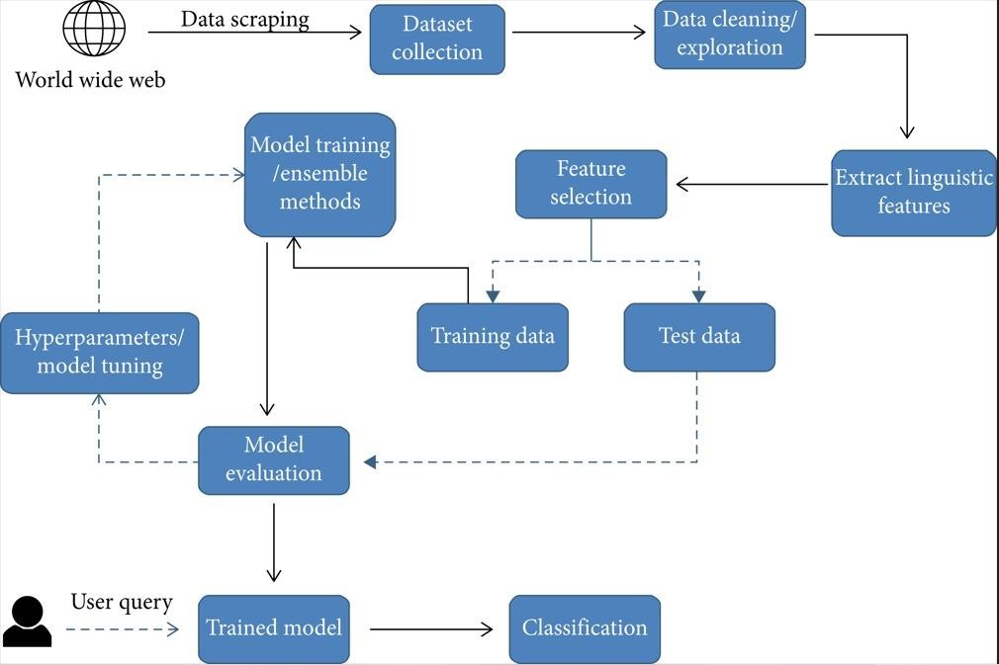

Figure 4.1: Architecture for training algorithms and classification of news articles.

Input is collected from various sources such as newspapers, social media and stored in datasets. System will take input from datasets. The datasets undergo preprocessing and the unnecessary information is removed from it and the data types of the columns are changed if required. Jupyter notebook and python libraries are used in the above step. Count vectorizer technique is used in the initial step. For fake news detection, we have to train the system using dataset. Before entering to the detection of fake news, entire dataset is divide into two datasets. 80% is used for training and 20% is used for testing.
In testing, the test dataset is given as input and the output is predicted. After the testing time, the predicted output and the actual output are compared using confusion matrix obtained .The confusion matrix gives the information regarding the number of correct and wrong predictions in the case of real and fake news. The accuracy is calculated by the equation No Of Correct Predictions/Total Test Dataset Input Size.
4.2 ALGORITHM FOR THE PROPOSED SYSTEM:
Step 1: Start
Step 2: Input is collected from various sources and prepare a dataset.
Step 3: Pre- processing of data is done and dataset is divided into 2 parts training and testing data.
Step 4: Count Vectorization technique is used to convert the train data into numerical.
Step 5: Logistic Regression algorithm is used to build the predictive model using the train data.
Step 6: Confusion matrix is obtained.
Step 7: Accuracy, Precision, Recall and F1 score is calculated.
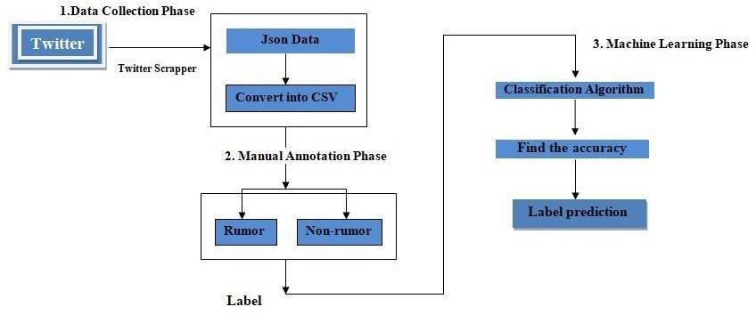
4.3 WORKFLOW
Figure 4.2: Workflow of Proposed System
CHAPTER 5
IMPLEMENTATION
  - PyCharm
PyCharm is an integrated development environment (IDE) for the Python programming language. It is developed by JetBrains and is available in both a free Community Edition and a paid Professional Edition. PyCharm provides a range of features to improve the productivity of Python developers. It includes a code editor with features such as syntax highlighting, code completion, and refactoring tools. It also provides debugging and testing tools, integration with version control systems, and support for popular Python frameworks such as Django and Flask. In addition to the basic features, PyCharm also includes several advanced tools for data analysis and scientific computing. It provides support for popular data analysis libraries such as NumPy, Pandas, and Matplotlib, and includes a scientific mode for interactive computing. PyCharm is designed to be easy to use and customizable. It includes several themes and color schemes, and supports custom plugins and extensions. It also provides a range of keyboard shortcuts and productivity tools to streamline the coding process. Overall, PyCharm is a powerful IDE for Python development that provides a range of features and tools to improve the coding experience. Its ease of use, customization options, and support for scientific computing make it a popular choice among Python developers.
  - LIBRARIES

    - Numpy

NumPy (Numerical Python) is a Python library for performing numerical computations. It provides a powerful N-dimensional array object, as well as functions for performing various mathematical operations on arrays.

Some of the key features of NumPy include:
- N-dimensional array object: NumPy provides a powerful array object that can hold and manipulate large arrays of homogeneous data. This makes it a great tool for performing numerical computations and data analysis.

- Mathematical functions: NumPy provides a wide range of mathematical functions for performing operations such as sin, cos, exp, log, and more.

- Broadcasting: NumPy allows for broadcasting, which is the ability to perform operations on arrays with different shapes and sizes. This makes it easier to perform computations on large datasets without having to manually align the data.

- Integration with other libraries: NumPy integrates well with other Python libraries such as Pandas, Matplotlib, and SciPy.

    - Pandas

Pandas is a popular Python library for data manipulation and analysis. It provides data structures and functions for working with structured data, including tabular data, time series, and more.

Some of the key features of Pandas include:

- Data Frame object: Pandas provides the Data Frame object, which is a 2-dimensional labeled data structure with columns of potentially different types. It is similar to a spreadsheet or SQL table, and is great for working with structured data.

- Data manipulation functions: Pandas provides a wide range of functions for manipulating data, including functions for filtering, sorting, merging, grouping, and aggregating data.

- Data visualization: Pandas integrates well with other Python libraries for data visualization, such as Matplotlib and Seaborn.
- Input/output functions: Pandas provides functions for reading and writing data in a variety of formats, including CSV, Excel, SQL databases, and more.

    - Matplotlib

Matplotlib is a popular Python library for creating data visualizations. It provides a wide range of functions for creating different types of plots, including line plots, scatter plots, bar plots, histograms, and more.
Some of the key features of Matplotlib include:

- Simple and flexible: Matplotlib is easy to use and can be customized to create a wide range of visualizations.

- Compatible with other libraries: Matplotlib integrates well with other Python libraries for data analysis, such as NumPy and Pandas.

- Multiple output formats: Matplotlib can create plots in a variety of formats, including PNG, PDF, SVG, and more.

- Extensive documentation: Matplotlib has extensive documentation and examples, making it easy to learn and use.

    - Seaborn

Seaborn is a Python data visualization library based on matplotlib that provides a high-level interface for creating informative and attractive statistical graphics. Seaborn makes it easy to create various types of statistical plots such as scatter plots, line plots, histograms, bar plots, heatmaps, and many others. Seaborn is built on top of matplotlib and integrates well with pandas data structures. It provides several built-in themes for styling the plots and supports customization options to make your visualizations stand out. Seaborn also provides advanced features for working with categorical data, such as grouped box plots, violin plots, and swarm plots. It also includes statistical functions for estimating and visualizing relationships between variables, such as regression plots and correlation matrices.
    - NLTK

NLTK (Natural Language Toolkit) is a popular Python library used for natural language processing (NLP) tasks. It provides a set of tools and resources for working with human language data, such as text corpora, lexical resources, grammars, and parsers. NLTK is widely used for various NLP tasks such as tokenization, stemming, lemmatization, part-of-speech tagging, sentiment analysis, and text classification. It also includes several machine learning algorithms for language processing, such as Naive Bayes, decision trees, and maximum entropy classifiers. In addition to the core NLP functionality, NLTK provides a suite of text processing and analysis tools, including concordance views, collocation finders, and dispersion plots. It also includes a range of corpus readers and corpora, such as the Brown Corpus, the Gutenberg Corpus, and the Treebank Corpus.

    - Tqdm

Tqdm is a Python library that provides a progress bar for iterators. It allows you to visualize the progress of an iterative task by displaying a progress bar with a percentage completion and estimated time remaining. Tqdm is designed to be easy to use and integrate into existing Python code. To use tqdm, you simply wrap your iterator with the tqdm function, and it will automatically display a progress bar as the iterator progresses. You can customize the progress bar by setting parameters such as the bar length, color, and refresh rate.

In addition to the basic progress bar functionality, tqdm provides several advanced features, such as the ability to track nested progress bars, estimate time remaining based on previous iterations, and display the progress bar in a Jupyter notebook. Overall, tqdm is a useful library for anyone working with iterative tasks in Python, making it easy to track progress and estimate completion times.

    - Scikit-learn

Scikit-learn is a popular machine learning library for Python that provides a range of tools and algorithms for data mining and analysis. It is built on top of other popular Python libraries such as NumPy, SciPy, and matplotlib, and provides a high-level interface for working with data and building machine learning models.

Scikit-learn includes a wide range of algorithms for classification, regression, clustering, and dimensionality reduction. It also includes tools for data preprocessing, feature extraction, and model selection. The library supports both supervised and unsupervised learning, and provides several evaluation metrics for measuring model performance. Scikit-learn is designed to be easy to use and integrates well with other Python libraries. It provides a consistent API for working with different types of models, making it easy to switch between algorithms and compare results. The library also includes detailed documentation and examples to help users get started quickly.

Overall, scikit-learn is a powerful and flexible machine learning library that is widely used in both academia and industry. Its ease of use, scalability, and extensive documentation make it a popular choice for machine learning practitioners and researchers

    - Pickle

The pickle module in Python is used for serialization and deserialization of Python objects. Serialization is the process of converting an object to a stream of bytes, while deserialization is the process of reconstructing the object from the stream of bytes. The pickle module allows you to save Python objects to a file and load them later.

The pickle module supports a wide range of Python objects, including lists, dictionaries, classes, and functions. It also supports more complex objects such as NumPy arrays and Pandas data frames. Once an object has been pickled, it can be stored in a file or transferred over a network, and later be unpickled to reconstruct the original object.
The pickle module provides two main methods for serialization and deserialization: pickle.dump () and pickle.load (). The dump () method serializes the object to a file, while the load () method deserializes the object from the file.

    - WordCloud

WordCloud is a Python library for generating word clouds from text data. Word clouds are visual representations of text data, where the size of each word corresponds to its frequency in the text. WordCloud allows you to create these visualizations with a few lines of Python code. To use WordCloud, you first need to prepare your text data. This typically involves cleaning and preprocessing the data to remove stop words, punctuation, and other noise. Once your data is cleaned, you can create a WordCloud object and pass in the text data as a string.

WordCloud provides several customization options to control the appearance of the word cloud, such as the color scheme, font, and background color. You can also use custom shapes for your word cloud, which allows you to create word clouds in different shapes and sizes. WordCloud is a useful tool for visualizing text data and identifying patterns and trends. It's commonly used in areas such as social media analysis, market research, and content analysis.

  - MACHINE LEARNING

Machine Learning (ML) is a sub-category of artificial intelligence that refers to the process by which computers develop pattern recognition, or the ability to continuously learn from and make predictions based on data, then make adjustments without being specifically programmed to do so.

Machine learning algorithms build a mathematical model based on sample data, known as "training data", in order to make predictions or decisions without being explicitly programmed to perform the task. Machine learning is closely related to computational statistics, which focuses on making predictions using computers.

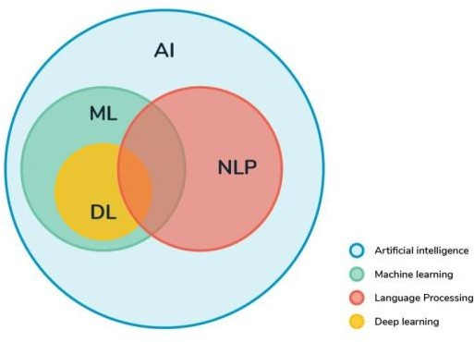
Fig 5.1: Graphical representation of relationship between various fields in artificial intelligence.

The study of mathematical optimization delivers methods, theory and application domains to the field of machine learning. "A computer program is said to learn from experience E with respect to some class of tasks T and performance measure P if its performance at tasks in T, as measured by P, improves with experience E. This is Alan Turing‘s definition of machine learning.

PREPROCESSING:

In any Machine Learning process, Data Preprocessing is that step in which the data gets transformed, or Encoded, to bring it to such a state that now the machine can easily parse it. In other words, the features of the data can now be easily interpreted by the algorithm. In this fake news detection, preprocessing is the major thing that should be done. Firstly, as the data dataset is collected from various sources unnecessary information should be removed, converted to lower case, remove punctuation, symbols, stop words.

STEPS IN TEXT PRE-PROCESSING:

Text Normalization:

Text normalization is a process of transforming text into a single canonical form. Normalizing text before storing or processing it allows for separation of required data from the rest so that the system can send consistent data as an input to the other steps of the algorithm.

Stop Word Removal

      - Stop Word:

A Stop Word is a commonly used word in any natural language such as “a, an , the, for, is, was, which, are, were, from, do, with, and, so, very, that, this, no, yourselves etc.”.

These Stop Words will have a very high frequency and so these should be eliminated while calculating the term frequency so that the other important things are given priority. Stop word removal is such a Pre-processing step which removes these stop words and thereby helping in the further steps and also reducing some processing time because the size of the document decreases tremendously.
Consider a Sentence

“This is a sample sentence, showing off the stop word removal”. Output after Stop word removal is:
[“Sample”, “sentence”, “showing”, “stop”, “word”, “removal”]

Note: Though Stop words refer to the most commonly used words in a particular language, there is no single universal list of stop words, different tools uses different stop words.

Stemming:
Stemming is a pre-processing step in Text Mining applications as well as a very common requirement of Natural Language processing functions. In fact it is very important in most of the Information Retrieval systems. The main purpose of stemming is to reduce different grammatical forms / word forms of a word like its noun, adjective, verb, adverb etc. to its root form. The goal of stemming is to reduce inflectional forms and sometimes derivationally related forms of a word to a common base form.
Eg: A stemmer for English should identify the strings "cats", "catlike", "catty" as based on the root "cat".

Rules of suffix stripping stemmers:

1. If the word ends in 'ed', remove the 'ed'.
2. If the word ends in 'ing', remove the 'ing'.
3. If the word ends in 'ly', remove the 'ly'.

Rules of suffix substitution stemmers:

1. If the word ends in ‘ies’ substitute ‘ies’ with ‘y’.

Generally this stemmer is used because of some word like families etc.

5.6 Count Vectorizer

Count Vectorizer tokenizes (tokenization means breaking down a sentence or paragraph or any text into words) the text along with performing very basic preprocessing like removing the punctuation marks, converting all the words to lowercase, etc. The vocabulary of known words is formed which is also used for encoding unseen text later. An encoded vector is returned with a length of the entire vocabulary and an integer count for the number of times each word appeared in the document.

Input to count vectorizer:

Document having 3 sentences
sam sam is super happy
sam sam is very sad

sam sam is scary angry

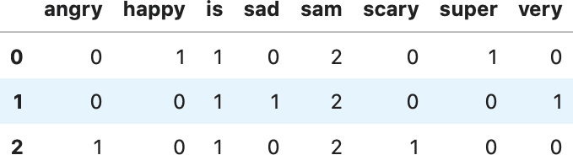
Output:

5.7 Logistic Regression Algorithm

- Step 1: Data Pre-processing step: In this step, we will pre-process/prepare the data so that we can use it in our code efficiently. It will be the same as we have done in Data pre-processing topic.
- Step 2: Fitting Logistic Regression to the Training set: We have well prepared our dataset, and now we will train the dataset using the training set. For providing training or fitting the model to the training set, we will import the Logistic Regression class of the sklearn library.
- Step 3: Predicting the test result: Our model is well trained on the training set, so we will now predict the result by using test set data.
- Step 4: Test accuracy of the result: Now we will create the confusion matrix here to check the accuracy of the classification. To create it, we need to import the confusion_matrix function of the sklearn library. The function takes two parameters, mainly y_true (the actual values) and y_pred (the targeted value return by the classifier).
- Step 5: Visualizing the test set result: Finally, we will visualize the training set result.
- Logistic Regression Equation:
The Logistic regression equation can be obtained from the Linear Regression equation. The mathematical steps to get Logistic Regression equations are given below.
We know the equation of the straight line can be written as:
In Logistic Regression y can be between 0 and 1 only, so for this let's divide the above equation by (1-y):
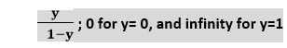
But we need range between -[infinity] to +[infinity], then take algorithm of the equation it will become:
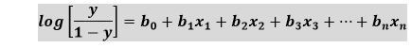
The above equation is the final equation for Logistic Regression.

- Logistic Regression Flowchart:
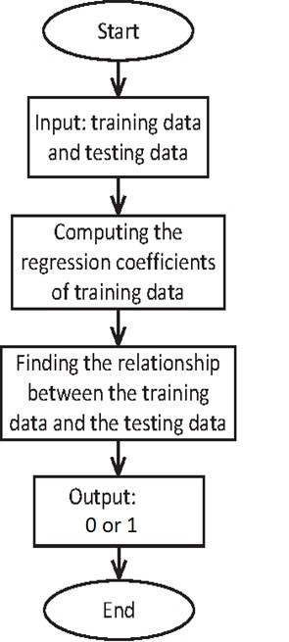
Fig 5.7: Logistic Regression Flowchart

5.8 Evaluation Measures:

Whenever we build Machine Learning models, we need some form of metric to measure the goodness of the model. Bear in mind that the “goodness” of the model could have multiple interpretations, but generally when we speak of it in a Machine Learning context we are talking of the measure of a model's performance on new instances that weren’t a part of the training data.
Determining whether the model being used for a specific task is successful depends on 2 key factors:
- Whether the evaluation metric we have selected is the correct one for our problem.
- If we are following the correct evaluation process. Here, I will focus only on the first factor selecting the correct evaluation metric.
    - Different types of evaluation metrics

The evaluation metric we decide to use depends on the type of NLP task that we are doing. To further add, the stage the project is at also affects the evaluation metric we are using. For instance, during the model building and deployment phase, we’d more often than not use a different evaluation metric to when the model is in production. In the first 2 scenarios, ML metrics would suffice but in production, we care about business impact, therefore we’d rather use business metrics to measure the goodness of our model.
With that being said, we could categorize evaluation metrics into 2 buckets.

      - Intrinsic Evaluation — Focuses on intermediary objectives (i.e. the performance of an NLP component on a defined subtask).
      - Extrinsic Evaluation — Focuses on the performance of the final objective.

5.8.2 Defining the metrics

- Accuracy

Whenever the accuracy metric is used, we aim to learn the closeness of a measured value to a known value. It’s therefore typically used in instances where the output variable is categorical or discrete — namely a classification task.
- Precision

In instances where we are concerned with how exact the model's predictions are we would use Precision. The precision metric would inform us of the number of labels that are actually labeled as positive in correspondence to the instances that the classifier labeled as positive.
- Recall

Recall measures how well the model can recall the positive class (i.e. the number of positive labels that the model identified as positive).
  - Coding:
- Importing The Libraries:
import pandas as pd
import seaborn as sns
import matplotlib. pyplot as plt
from tqdm import tqdm
import re
import nltk
from wordcloud import WordCloud
import pickle

- Preprocessing:

def preprocess_text(text_data):
preprocessed_text = []

for sentence in tqdm(text_data):
sentence = re.sub(r'[^\w\s]', '', sentence)
preprocessed_text.append(' '.join(token.lower()
for token in str(sentence).split()
if token not in stopwords.words('english')))

return preprocessed_text

- Training and Testing of data:

from sklearn.model_selection import train_test_split
from sklearn.metrics import accuracy_score
from sklearn.linear_model import LogisticRegression

x_train, x_test, y_train, y_test = train_test_split(data['text'],
data['class'],
test_size=0.25)

- Applying Count Vectorizer:

from sklearn.feature_extraction.text import TfidfVectorizer
vectorization = TfidfVectorizer()
x_train = vectorization.fit_transform(x_train)
x_test = vectorization.transform(x_test)

- Predicting Accuracy:
from sklearn.linear_model import LogisticRegression

model = LogisticRegression()
model.fit(x_train, y_train)
import pickle
with open('fake_news_new.pkl', 'wb') as f:
pickle.dump(model, f)

print(accuracy_score(y_train, model.predict(x_train)))
print(accuracy_score(y_test, model.predict(x_test)))

- Obtaining Confusion Matrix:

from sklearn import metrics
cm = metrics.confusion_matrix(y_test, model.predict(x_test))

cm_display = metrics.ConfusionMatrixDisplay(confusion_matrix=cm,
display_labels=[False, True])

cm_display.plot()
plt.show()

CHAPTER 6
TESTING
The reason for testing is to seek out blunders. Testing is that the manner toward endeavoring to seek out every doable blame or disadvantage in a very work item. It offers associate approach to visualize the quality of elements, sub gatherings, congregations similarly as a completed item it's the manner toward active programming with the goal of guaranteeing that the computer code. Framework lives up to its wants associated shopper needs and doesn't flop in an unsuitable manner. There area unit completely different types of check. every check kind tends to a selected testing requirement.

TYPES OF TESTS

UNIT TESTING
Unit testing includes the structure of experiments that approve that the inward program principle is functioning, which program inputs turn out substantial yields. All alternative branches and within code stream need to be approved. It's the attempting of individual programming units of the appliance. It's done when the finishing of a private unit before combination. This can be a basic testing, that depends on info of its development and is obtrusive. Unit checks perform elementary tests at half level and test a selected procedure, application, and to boot framework style. Unit tests guarantee that each extraordinary manner of a business procedure performs exactly to the recorded particular and contains clearly characterized info sources and anticipated outcomes.

INTEGRATION TESTING

Joining tests are intended to test incorporated programming segments to decide whether they really keep running as one program. Testing is occasion driven and is progressively worried about the fundamental result of screens or fields. Incorporation tests exhibit that despite the fact of the segments were separately fulfillment, as appeared by effectively unit testing, the mix of parts is right and reliable. Coordination testing is explicitly gone for uncovering the issues that emerge from the blend of segments.

VALIDATION TESTING
A building approval test (EVT) is performed on first building models, to guarantee that the essential unit performs to plan objectives and particulars. It is imperative in recognizing plan issue and fathoming them as right off the bat in the structure cycle as could reasonably be expected, is the way to keeping ventures on schedule and inside spending plan. Over and over again, item plan and execution issues are not identified until late in the item improvement cycle — when the item is prepared to be transported. The familiar saying remains constant. It costs a penny to roll out an improvement in building, a dime underway and a dollar after an item is in the field.

Check is a Quality control process that is utilized to assess whether an item, administration, or framework conforms to guidelines, details, or conditions forced toward the beginning of an improvement stage. Check can be being developed, scale-up, or creation. This is regularly an inside procedure.
Approval is a Quality affirmation procedure of setting up proof that gives a high level of confirmation that an item, administration, or framework achieves its planned prerequisites. This regularly includes acknowledgment of qualification for reason with end clients and other item partners.
The testing process overview is as follows:
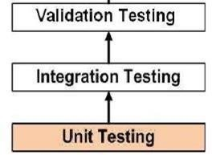

Fig 6.1: The Testing process

SYSTEM TESTING
Framework testing of programming or equipment is trying led on a total, coordinated framework to assess the framework's consistence with its predetermined prerequisites. Framework testing falls inside the extent of discovery testing, and all things considered, ought to require no learning of the inward plan of the code or rationale. When in doubt, framework testing takes, as its information, the majority of the incorporated programming segments that have effectively passed joining testing and furthermore the product framework itself coordinated with any relevant equipment systems.
Framework testing is a progressively constrained sort of testing, it looks to identify absconds both inside the between collections and furthermore inside the framework all in all. Framework testing is performed on the whole framework with regards to a Functional Requirement Specifications as well as a System Requirement Specification. Framework testing tests the structure, yet in addition the conduct and even the trusted desires for the client. It is likewise planned to test up to and past the limits characterized in the product necessities specifications.

  - Scenario of Test Cases

Test case ID | 1
Test case Name | Fake News Identification
Test case Description | User can identify the news is Fake or Real
Expected Result | When the user clicks on detect button it displays Fake news and its accuracy
Actual Result | As Expected

Test case ID | 2
Test case Name | Real News Identification
Test case Description | User can identify the news is Fake or Real
Expected Result | When the user clicks on detect button it displays Fake news and its accuracy
Actual Result | As Expected
CHAPTER 7
SNAP SHOTS

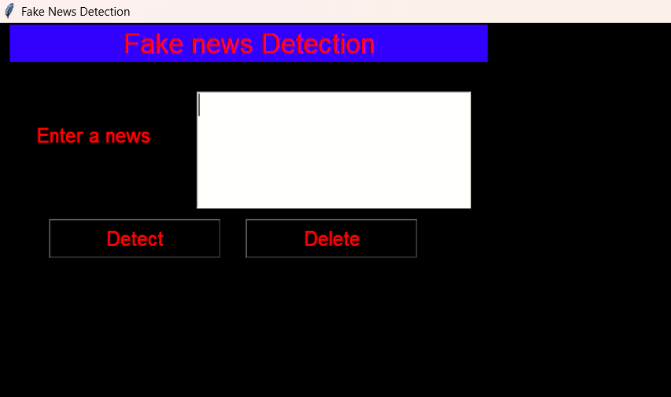
Fig 7.1: Giving Input

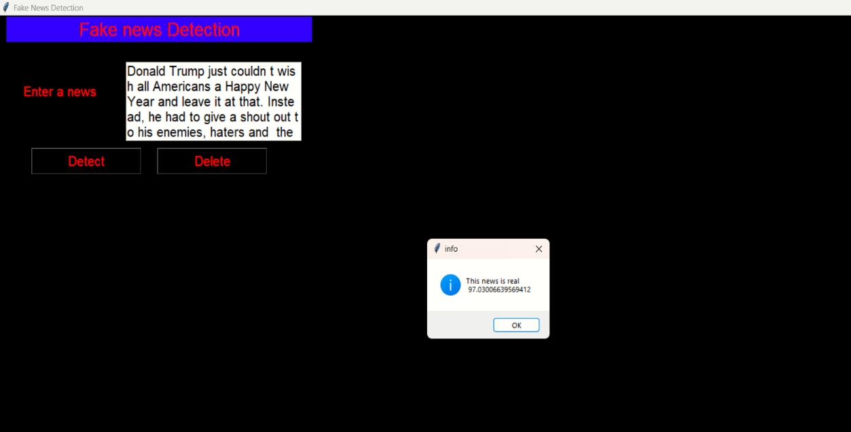
Fig 7.2: Output Detection (Real)

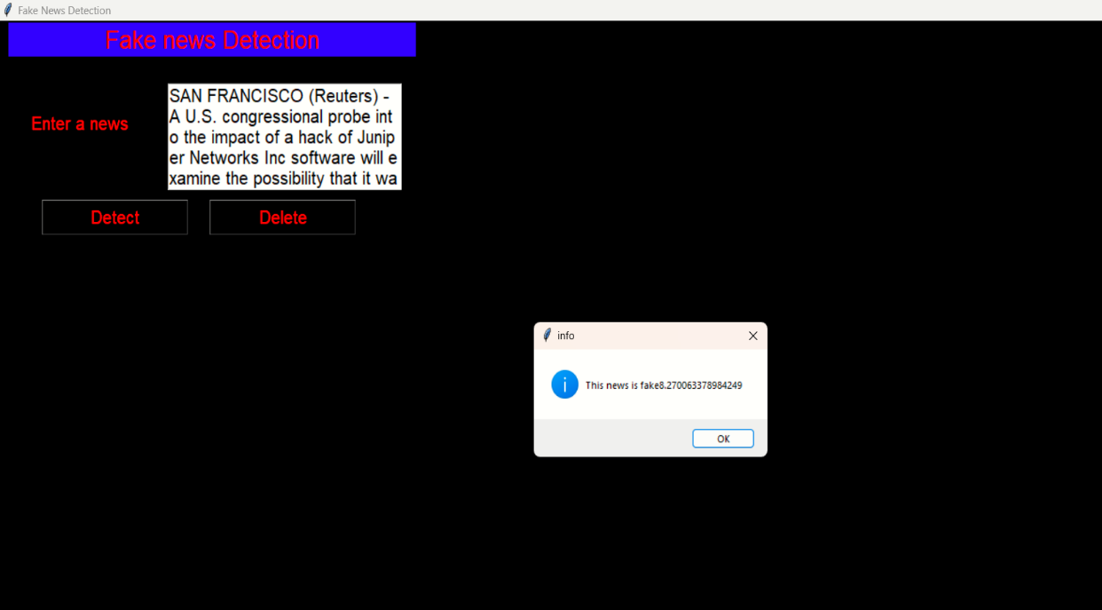
Fig 7.3: Output Detection (Fake)

CONCLUSION

With the increasing quality of social media, additional individuals consume news from social media rather than ancient fourth estate. Social media has conjointly been accustomed unfold pretend news, that has sturdy negative impacts on individual users and broader society. We have a tendency to explore the pretend news drawback by reviewing existing literature in two phases characterization and detection. Within the characterization part, we have a tendency to introduced the essential ideas and principles of faux news in each ancient media and social media. Within the detection part, we have tendency to reviewed existing pretend news detection approaches from a knowledge mining perspective, together with feature extraction and model construction. We have tendency to conjointly more mentioned the datasets, analysis metrics, and promising future directions in pretend news detection analysis and expand the sphere to alternative applications.

FUTURE SCOPE

- We want to use web scraping and get the data from various social media and websites by ourself and use them in our system.

- We also want to improve the accuracy by query optimization

REFERENCES

[1] Lakshmi Panneerselvam - Published On June 28, 2021 and Last Modified On
August 27th, 2022.

[2] Kajal Kumari - Published On July 19, 2021 and Last Modified On September 6th,
2022.

[3] Nathan - Building a fake news classifer using natural language processing.
(https://towardsdatascience.com/building-a-fake-news-classifier-using-natural -
processing-83d911b237e1).

[4] Shloka Gilda - Evaluating Machine Learning Algorithms for Fake News Detection
2017 IEEE 15th Student Conference on Research and Development (SCORED).

[5] Mykhailo Granik, Volodymyr Mesyura -- Fake News Detection Using Naïve
Bayes Classifier||, 2017 IEEE First Ukraine Conference on Electrical and Computer
Engineering (UKRCON).

[6] Gravanis, G., et al., Behind the cues - A benchmarking study for fake news
Detection. Expert Systems with Applications, 2019.28: p. 201- 213.

[7] Zhang, C., et al., - Detecting fake news for reducing misinformation risks using
Analytics approaches. European Journal of Operational Research, 2019.

[8] Zakeri, A. and A. Hokmabadi - Efficient feature selection method using real-
Valued grasshopper optimization algorithm. Expert Systems with Applications,
2019.119: p. 61-72.

[9] Bondielli, A. and F. Marcelloni - A survey on fake news and rumors detection
Techniques. Information Sciences, 2019.

[10] Poonam Tijre R - Fake news detection using Naïve byes, SVM, Neural Network
and LSTM.

[11] Asha J. and Meenakowshalya A - Fake News Detection Using N-Gram
Analysis and Machine Learning Algorithms.

